Practice for 5.MD.2—Just Practice
1. Use the data to create line plot.
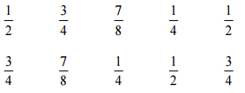

2. Create another line plot using this data:

$\frac{2}{3 } , \frac{1}{3} ,1 \frac{2}{3} ,2\frac{2}{3 } , \frac{1}{3} ,1 \frac{2}{3}$

$\frac{2}{3} , 1 \frac{1}{3} , 2\frac{1}{3} , 3 \frac{2}{3}$ ,

3. Just another bit of practice:

$4 , \frac{1}{4} ,1 \frac{3}{4} ,2\frac{2}{4 } , \frac{1}{2} ,1 \frac{2}{4}$

$\frac{2}{4} , 1 \frac{1}{2} , 2\frac{1}{4} , 3 \frac{2}{4}$ ,

